How to setup DB2assist

1. Be sure to use mozilla firefox, with other browsers it will not work.
2. Open your mozilla and press ctrl+shift+K to brink up console
3. Type “allow pasting” and test pasting something from clipboard into the line, if it works, proceed to next step, if it doesn’t work, go to about:config and set the setting devtools.selfxss.count to some high value, like 100.
4. Go to <https://tampermonkey.net/> and install addon
5. Click this icon and press create new script

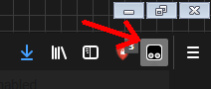

1. Open DB2 script support.txt, copy and overwrite everything in new userscript you opened before, press file and save. You can close the tab now.
2. Now go to DB2 and check: the icon should have red 1 (script running) and record number field will be highlighted. This script is changing names of pages you are currently on in DB2, so the script can orient itself. Without it it wont do anything.

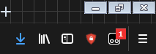

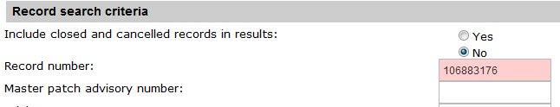

1. Rename DB2.0.ex to DB2.0.exe and run it
2. Press batch close button, you will be asked if you want to create new file, click yes and paste numbers of apars you want to close 1 by line, make sure no trailing spaces or empty lines are present. Save and close.
3. Make sure DB2 is on active firefox tab now. Now fill in reason for not applicability, in case you have it filled from previous session and it still applies, press no change. Otherwise press OK.
4. Now script will open js console and start pasting commands. Script was designed to work in the background but it has some limitations.
   1. It uses clipboard so **using copypasta while running can lead to error**.
   2. Deactivating window or **switching tab in mozilla will cause error**.
   3. Running on locked screen is not tested and probably wont work.

For any **problems or suggestion contact ln219r**. Script was developed pro-actively.